Winter Carnival Activities will be postponed until later in March!
The Book Fair is Rescheduled for March 26 & 27
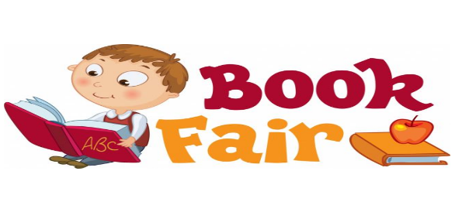

The Grade 4 & 5 Snowshoe Trip is postponed
. 